KING’S OWN INSTITUTE*
Success in Higher Education

GROUP ASSIGNMENT COVERSHEET

Subject Code & Name: ICT711 Programming and Algorithms T126 Lecturer's/Tutor's name: Saad Sajid Hashmi
Assignment Title: Book Recommendation System
Declaration
(This declaration must be completed by all students in the group or the assignment will not be marked.)

We, the undersigned, certify the following:
• We have read and understood the Student Academic Misconduct Policy
• This assignment is our own work based on our personal study and research.
• We have acknowledged all material and sources used in the preparation of this assignment, including any material generated in the course of our employment.
• The assignment has not previously been submitted for assessment in this or any other unit.
• We have not copied in part or in whole or otherwise plagiarized the work of other students.
• We have read and understand the criteria used for assessment.
• The assignment is within the word and page limits specified in the unit outline.
• The use of any material in this assignment does not infringe the intellectual property / copyright of a third party.
• We understand that this assignment may undergo electronic detection for plagiarism, and an anonymous copy of the assignment may be retained on the database and used to make comparisons with other assignments in future.
• By completing this coversheet in full and submitting this assignment electronically, we are bound by the conditions of the KOI's Student Academic Misconduct Policy and the declaration on this coversheet.

 | Family Name | Given Name(s) | Student ID | Tutorial Code | Contribution Percentage | Signature
Student 1 | Pokhrel | Adesh | 20037476 | ICT711
Student 2 | Khadka | Dipesh | 20038804 | ICT711
Student 3 | Sharma | Bijaya | 20037538 | ICT711
Student 4 | Katuwal | Parisha | 20037391 | ICT711
Student 5 | Bhandari | Samir | 20037370 | ICT711

Assignment Receipt
Subject Code & Name: ICT711 Programming and Algorithms T126 Lecturer's/Tutor's name: Saad Sajid Hashmi
Assignment Title: Book Recommendation System

 | Family Name | Given Name(s) | Student ID | Tutorial/ Code | Signature
Student 1 | Pokhrel | Adesh | 20037476 | ICT711
Student 2 | Khadka | Dipesh | 20038804 | ICT711
Student 3 | Sharma | Bijaya | 20037538 | ICT711
Student 4 | Katuwal | Parisha | 20037391 | ICT711
Student 5 | Bhandari | Samir | 20037370 | ICT711

Table of Content
1. Background 7
1.1 Introduction 7
1.2 Aim 8
1.3 Objectives 8
1.4 Problem Statement 8
1.5 Scope of the project 8
1.6 System Overview 9
2. Object-Oriented Programming (OOP) Concepts 9
2.1 UML Diagrams 9
2.1.1 Class Diagram 9
2.1.2 Relationships Between Classes 10
2.2 Inheritance 10
2.3 Polymorphism 10
2.4 Abstraction 10
2.5 Encapsulation 10
3. System Design 11
3.1 System Architecture 11
3.2 Description of Classes 11
3.2.1 User Class 12
3.2.2 Admin Class 12
3.2.3 Reader Class 12
3.2.4 Book Class 12
3.2.5 BookManager Class 12
3.2.6 Recommendation Engine Class 12
3.2.7 File Manager Class 12
3.3 Attributes and Methods 13
3.4 Data Flow of the System 13
4. System Functionality 14
4.1 User Registration 14
4.2 Adding a New Book 14
4.3 Viewing Records 14
4.3.1 Search by Book ID 15
4.3.2 Search by Title 15
4.3.4 Search by Genre 15
4.4 Updating Records 15
4.5 Deleting Records 15
4.6 Book Recommendation Feature 15
4.7 Periodic Evaluation 15
5.0 Utilising Java Collections 16
5.1 ArrayList Implementation 16
5.2 Queue or LinkedList Usage 16
5.3 Choice of Collection 16
6 File Handling 17
6.1 Reading Data from Files 17
6.2 Writing Data to Files 17
6.3 CSV/Text File Structure 17
7 Exception Handling 18
7.1 File Handling Exceptions 18
7.2 Invalid Input Exceptions 18
7.3 Try-Catch Implementation 18
8 CLI (Command-Line User Interface) 19
8.1 Main Menu Design 19
8.2 User Interaction Flow 19
8.3 Menu Navigation 19
9 Program Output 20
9.1 Test Cases 20
9.2 Program Screenshots 21
9.3 Output Verification 21
10 Conclusion 22
11 Java Source-Code Link 22
12 References 23
13 Appendix 24

1. Background

Introduction
Book recommendation system is a Java-based software program that provides easy management of book and user information through the process of CRUD (Create, Read, Update and Delete). The software allows users and administrators to create, read, update and delete the records in the program according to their needs. In addition to managing records, it provide recommendations for appropriate books based on the user's preferences such as author.
This software has been written using certain aspects of OOP like inheritance, polymorphism, abstraction and encapsulation. Other key features that have been used to build this software include the use of Java Collections such as ArrayList to store data and exceptions for reading, writing and processing files. Further, file reading and writing has also been implemented for creating and editing text or CSV files for user and book details.

Aim
The aim of this project are:
- To develop a text-based book recommendation system using Java.
- To implement CRUD operations for managing books and user records.
- To implement file handling for reading and writing data.
- To handle errors and invalid inputs using exception handling.
- To create a simple and user-friendly command-line interface (CLI).

Objectives
The objectives of the project are as follows:
• To design a Java application with a number of interacting classes and objects.
• To define an abstract class and specialized classes to show abstraction and inheritance.
• To perform Create, Retrieve, Update, and Delete (CRUD) operations.
• To read and write to a CSV file for user information.
• To achieve in-memory data management with Java Collections, particularly ArrayList.
• To use try-catch blocks for error handling.

Problem Statement
Book record management can be time-consuming, inefficient, and error-prone, particularly in the case of a large number of books and users. Manual book management systems are inefficient for managing records, searching books, updating information and recommending books to users.
The Book Recommendation System solve these problems by offering an automated solution that enables efficient manipulation of book and user records through create, read, update and delete operations. The system also enhances the user's experience by providing book recommendations based on user preferences and ratings. The system uses object-oriented programming, file handling, and Java Collections to offer a maintainable and efficient approach to book management and recommendations.

Scope of the project
The book recommendation system aims to manage books and user records via the command-line. Admins can perform CRUD (Create, Read, Update, Delete) operations on the records, and users can view and receive book suggestions. The system also supports file operations to store and read data, error handling for exceptions, and uses Java Collections to store and manipulate data.

System Overview
The Book Recommendation System is a Java application that stores and manages book and user information. The system uses classes such as User, Admin, Reader, Book, and RecommendationEngine to organize functionalities efficiently.
It allows users to search for books by name, author, and category, and administrators can perform create, read, update, and delete (CRUD) operations. The book recommendation system uses ratings and categories to recommend books, enhancing user interactivity and experience.

2. Object-Oriented Programming (OOP) Concepts

2.1 UML Diagrams
In the UML Diagram, we have followed the MVC architecture which means Model, View, and Controller. Here, we have LibraryUser and its subclasses i.e. StandardMember and PremiumMember acting as Model. It encapsulates data and business logic such as evaluation of points. Our Controller is BookRecommendationSystem class which is responsible for handling user operations and managing data via the csv file. The View in our UML diagram is members.csv file which displays output and interaction between user and the system.
In the diagram, we have used “+” plus sign to denote public methods, while “-” minus sign denotes private attributes. The triangle symbol denotes the inheritance (IS-A).
UML text structure:
- LibraryUser (abstract): id, name, email, booksRead, points, preferredGenre, getters, setters, evaluate()
- StandardMember extends LibraryUser: overridden evaluate()
- PremiumMember extends LibraryUser: overridden evaluate()
- BookRecommendationSystemCLI or main controller: ArrayList<LibraryUser>, load, save, add, query, update, delete, recommend, evaluate

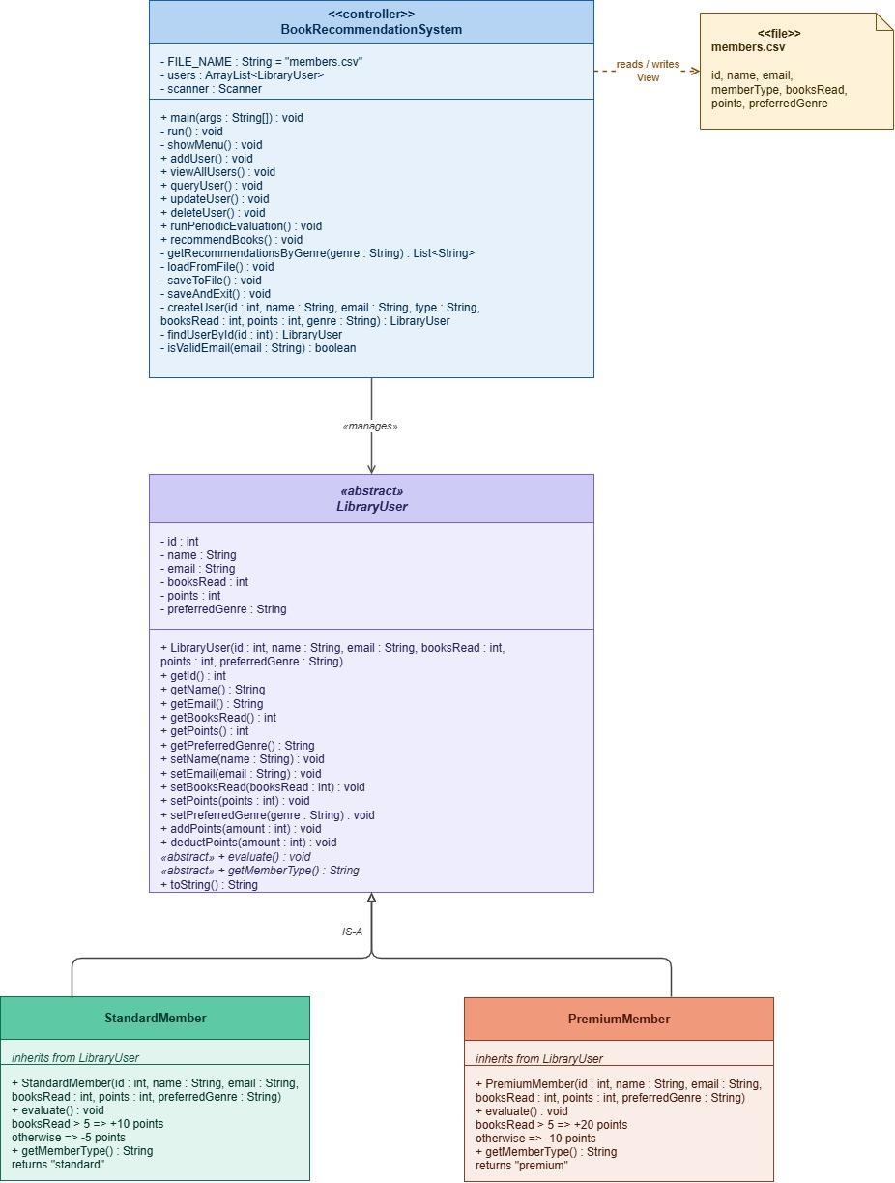

2.1.1 Relationships Between Classes
StandardMember and PremiumMember are specialisations of LibraryUser because they inherit common attributes and methods from the abstract superclass. The main controller has an association with LibraryUser objects because it manages them in an ArrayList at run-time.
The CSV file is connected with the controller as a data source because the records are read from the file when the program starts and write to the file when they are saved. This is significant since file persistence is a required feature of the specification.

2.2 Inheritance
Inheritance is shown by creating LibraryUser as a general abstract class and then extending this to create StandardMember and PremiumMember. This enables common fields such as ID, name, email, number of books read, points and favourite genre to be implemented once in the parent class and extend into the subclasses.
This increases code reuse and avoids redundancy, which meets the project's requirement to create class hierarchies that allow reuse and extension for specific behaviours. The subclasses only have to implement the different behaviour, i.e. periodic assessment rules
.

2.3 Polymorphism
Polymorphism is demonstrated by putting StandardMember and PremiumMember objects into a collection of LibraryUser references. As the program iterates over the users and calls evaluate(), the appropriate subclass variation is applied even though the references are to the superclass.
This means that the system can use the same logic to manage multiple types of members but with different results for each type, as specified in the project brief​. Regular users get a different point increase to premium members for the same evaluation event.

2.4 Abstraction
Abstraction is achieved through the abstract class LibraryUser, which defines common fields and an abstract method for evaluation, but does not define a single method for all users. The actual implementation is left to the subclasses (StandardMember and PremiumMember) to implement evaluation.
This allows us to hide unnecessary detail from the rest of the program and facilitates a more elegant design focusing on common abstract behaviour across users.The abstract parent class is in line with the project brief’s requirement for abstraction in the system design.
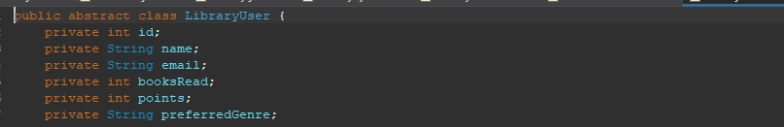

2.5 Encapsulation
Encapsulation is achieved by making the LibraryUser attributes private and providing access to them using getter and setter methods​. This ensures that fields are not directly modified without checks and that the class itself controls how its fields are accessed and modified.
This makes the class design more maintainable and secure, and is important in a multi-class object-oriented program. Encapsulation also allows for future growth if extra code is required for the setters or additional methods.
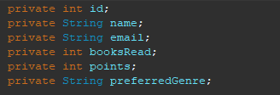

3. System Design
The system design combines an object-oriented user hierarchy, a file-based persistence layer, a Java Collections data structure, and a command-line user interface. Its architecture is intentionally simple so that the implementation remains manageable within the assignment scope while still demonstrating the requested concepts.

3.1 System Architecture
The architecture follows a simple layered flow: the CSV file provides persistent data, the controller class loads it into memory, the collection stores active objects, the CLI presents options to the user, and output is saved back to file after changes. The main internal entities are the member classes rather than separate user, admin, reader, and book objects, which means the current implementation is a focused member-management design rather than a full library-catalogue architecture.
A concise architecture description is:
- Input layer: members.csv file.
- Processing layer: controller logic for CRUD, recommendations, and evaluation.
- Domain layer: LibraryUser, StandardMember, PremiumMember.
- Interface layer: command-line menu aligned with the project brief.

3.2 Description of Classes
The implemented code contains a smaller class set than the section template suggests, so this report maps the requested headings to the actual project design where necessary. Classes such as Admin, Reader, Book, BookManager, RecommendationEngine, and FileManager are not explicitly present in the original supplied code, so they are discussed here as logical roles handled by the main controller rather than as separate implemented files.

3.2.1 User Class
The closest implemented form of a user class is LibraryUser, which acts as the abstract parent for all member records .It stores the core member information and defines the common interface used by the rest of the program.

3.2.2 Admin Class
A separate Admin class is not implemented in the supplied code.Instead, the main controller class performs the administrative role by presenting options for adding, viewing, querying, updating, deleting, evaluating, and saving records.

3.2.3 Reader Class
A distinct Reader class is also not implemented in the current codebase.The behaviour of a library reader is represented through member records held in StandardMember and PremiumMember, both of which track reading activity through the booksRead field.

3.2.4 Book Class
The current system does not include a dedicated Book entity because the recommendation feature works through genre-based output rather than a stored book catalogue. Therefore, the system is better described as a member-centric recommendation tool rather than a complete book inventory system.

3.2.5 BookManager Class
A separate BookManager class is not part of the supplied implementation. Its logical responsibilities, such as displaying recommendation-related output and handling user-facing operations, are combined in the main controller.

3.2.6 Recommendation Engine Class
A separate RecommendationEngine class is not explicitly present in the original code, although recommendation logic is included through a method in the controller.In the improved version of the program, this logic can be described as genre-based rule processing that returns recommended titles according to the user’s preferred genre.

3.2.7 File Manager Class
The current implementation does not define a standalone FileManager class. Filereading and file-writing responsibilities are handled by methods such as loadFromFile() and saveToFile() inside the controller class, although separating them into a dedicated file manager would improve maintainability in a future version.

3.3 Attributes and Methods
The most important attributes in the system are id, name, email, booksRead, points, and preferredGenre, all stored in LibraryUser. Important methods include getters and setters, addPoints(), deductPoints(), the abstract evaluate(), and controller-side methods for add, query, update, delete, recommend, load, and save operations.
Class | Key Attributes or methods | Source
LibraryUser | id, name, email, booksRead, points, preferredGenre, getters, setters, evaluate() | LibraryUser.java
StandardMember | Overridden evaluate | StandardMember.java
PremiumMember | Overridden evaluate | PremiumMember.java
Controller | add, view, query, update, delete, evaluate, recommend, load, save | BookRecommendationSystemCLI.java

3.4 Data Flow of the System
The data flow begins when the program opens members.csv and reads user records into an inmemory ArrayList. The admin then interacts with the system through the CLIto perform operations such as insert, query, update, delete, and evaluation. After each major data-changing operation, the updated collection is written back to the CSV file so that the changes remain available in the next run of the program. This readprocess write flow is consistent with the assignment’s requirement for file-based storage and admin interaction after file loading.

4. System Functionality
The project specification lists required system functions including adding a user, querying user information, updating and deleting records, and overseeing periodic evaluation. The developed system implements these features around member records and extends them with a recommendation output based on preferred genre.

4.1 User Registration
User registration is represented in this project by the add-user operation, where a new member record is created by entering ID, name, email, member type, books read, points, and preferred genre. The controller then constructs either a StandardMember or PremiumMember object and stores it in the collection.
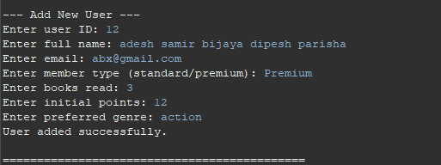

4.2 Adding a New Book
The current implementation does not contain a dedicated book catalogue or book-creation features. If this section must remain in the final template, it should be stated that the current project focuses on adding users rather than storing separate book entities, and recommendations are genre-based rather than title-database driven.
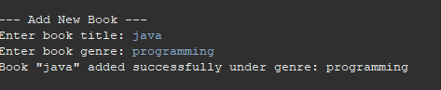

4.3 Viewing Records
Viewing records is supported through the ability to display all users and to search for selected users through query operations. This makes it possible for the admin to inspect stored information before updating or deleting records.
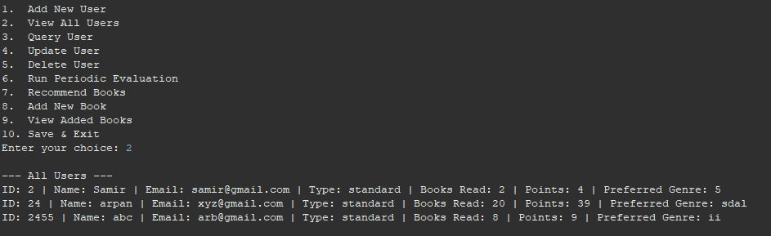

4.3.1 Search by Book ID
The current code does not support search by book ID because the system manages users rather than stored book objects.This heading can be adapted in the report to explain that the implemented equivalent is searchby user ID, which is already provided in the query operation

4.3.2 Search by Title
Search by title is not implemented because there is no dedicated Book class or book collection in the supplied system [file:2].The nearest implemented search function is by user name

4.3.4 Search by Genre
The data model does contain a preferredGenre field for each user, but the original code does not implement a separate query operation by genre. Genre is currently used more directly for recommendation output than as a standalone search field.

4.4 Updating Records
The system supports record updating by allowing a selected user to be modified after locating the record by ID​. In the improved CLI version, the update behaviour is more complete because additional fields such as name, email, and preferred genre can also be changed rather than only books read and points.

4.5 Deleting Records
Deleting records is implemented through a user-ID-based delete operation, allowing the admin to remove a specific member from the collection. The deletion is then saved back to the CSV file so that the removed record is no longer present in subsequent runs.
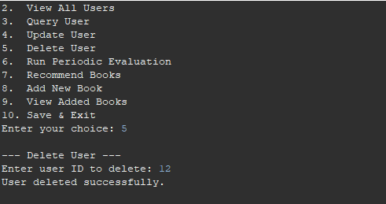

4.6 Book Recommendation Feature
The recommendation feature is implemented as a simple rule-based function that displays book suggestions to a selected user​. In the original GUI code, the same titles were shown for all members, but the improved version is better aligned with the available data because it uses the member’s preferred genre to return more relevant titles.

4.7 Periodic Evaluation
Periodic evaluation is implemented through the evaluate() method in each subclass. If a standard member has read more than five books, ten points are added; otherwise five points are deducted, while premium members receive twenty points or lose ten points based on the same threshold.
This behaviour directly matches the specification requirement for monitoring status, triggering positive and negative feedback, and applying reward or penalty actions to system entities. It also provides one of the clearest demonstrations of runtime polymorphism in the system.

5 Utilising Java Collections
Disciplines of Data Science and BigData: Project Specification (LW) requires the use of Java Collections to store system objects in memory. The solution uses ArrayList to store user objects, which suits this system's requirements in terms of size and type of operations.

5.1 ArrayList Implementation
The main controller uses an ArrayList<LibraryUser> to store users allowing both StandardMember and PremiumMember objects to be stored in a single collection . It supports iterative traversal, insertion, deletion and multiple display operations at run time.

5.2 Queue or LinkedList Usage
In this version, Queue and LinkedList are not used, but the specification requires students to think about the advantages of using advanced data structures​. A Queue could be beneficial if requests for evaluation or recommendation actions occur in a first in first out fashion and a LinkedList could be used if the need to insert records and remove records in the middle of a collection becomes a priority.

5.3 Choice of Collection
ArrayList is justified because the system simply processes record data from a small CSV data file. Its simplicity, support for iteration and compatibility with CRUD operations justifies its use for this system. For larger applications a hashmap (for map-like behaviour) or treemap (for tree-like behaviour) could be used to boost search times, but for this assignment, the simplicity of ArrayList and the clarity of its algorithms is more important than extra complexity.

6 File Handling
Data is to be read in from and written to a CSV file called members.csv to complete the assessment requirements. The system is persisting the user data to and from this file before and after the admin's actions.

6.1 Reading Data from Files
But the system loads the CSV file in the beginning, with buffer file input, ignoring the header, splitting each line into fields, and translating the fields into LibraryUser objects. This enables the system to start with existing data, which meets the 10 users loaded before processing requirement.

6.2 Writing Data to Files
The application writes the updated collection back to members.csv after an add item, update items, delete items or evaluate operations using file output techniques . This enables user data to be preserved and for changes made in one running of the system to persist to the next.

6.3 CSV/Text File Structure
The CSV file is structured with the header id, name, email, memberType, booksRead, points, preferredGenre, and each row corresponds to a user. This matches the attributes in LibraryUser and member subclasses.
Below is an example row:
1, Adesh Sharma, adesh@example.com, standard,12,75,Fiction

7 Exception Handling
According to the project requirements, try-catch blocks are required to handle invalid user input and file-related errors. The supplied code implements exception handling for user input, file reading, and file saving. However, the improved CLI version enhances this by preventing silent failures and providing more descriptive error messages.

7.1 File Handling Exceptions
File handling exceptions occur when the program is unable to read from or write to the CSV file. The code manages these situations using try-catch blocks within the file loading and saving methods. This ensures that the application does not crash immediately if file access fails, and instead handles the error gracefully.

7.2 Invalid Input Exceptions
Invalid input exceptions are raised when the user provides incorrect data, such as a non-numeric ID or improperly formatted values. These exceptions are handled through try-catch blocks during input processing. When such errors occur, the program displays an appropriate error message and prompts the user to re-enter valid input.

7.3 Try-Catch Implementation
Try-catch blocks are implemented across key operations, including add, query, update, delete, load, and save. It is important to note that effective exception handling goes beyond simply catching errors. Since some errors may not be immediately clear, the improved CLI version incorporates better validation and more informative error messages to enhance usability and debugging.
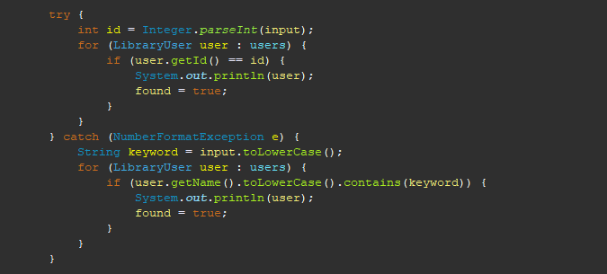

8 CLI (Command-Line User Interface)
The system specification requires a character-based user interface. In this project, a command-line interface (CLI) is used to allow the administrator to select and perform operations. While the initial version was developed using Swing, the final system is better aligned with the requirements through its CLI implementation.

8.1 Main Menu Design
The main menu presents a numbered list of operations, enabling the administrator to make consistent selections. The available options include: add user, view all users, search user, update user, delete user, perform periodic assessment, recommend books, and save and exit. These options reflect the core features of the system.

8.2 User Interaction Flow
The interaction process begins with loading user data. The system then displays the menu and prompts the user to select an option. Based on the selection, the program performs actions such as adding new records, searching, updating, deleting, evaluating, or recommending. After completing each task, the system returns to the main menu.

8.3 Menu Navigation
The menu design is simple and intuitive, making it suitable for an educational command-line application. After each operation, the program returns to the main menu. This loop continues until the user chooses to exit, at which point the system saves all data and terminates.

9 Program Output
Testing is essential to ensure that all required functionalities operate correctly and that invalid conditions are handled appropriately. In this project, key testing areas include file loading and saving, CRUD operations, evaluation rules, and handling of invalid inputs.

9.1 Test Cases
Some of the test cases are given below:
Test case | Input or action | Expected result
Load CSV ﬁle | Start program with valid  members. csv | Users are loaded into memory
Add valid user | Enter a new unique ID and valid details | New member is stored and saved
Add duplicate  ID | Enter an ID already present in ﬁle | System rejects insertion in improved version
Query by ID | Enter an existing ID | Matching user details are displayed
Query by name | Enter part of a stored name | Matching user details are displayed
Update user | Enter valid modiﬁed values | Selected record changes and saves
Delete user | Enter an existing ID | Record is removed and ﬁle updates
Run evaluation | Trigger evaluation option | Points are adjusted per member type
Invalid ﬁle | Missing or inaccessible CSV ﬁle | Error is handled without uncontrolled crash

9.2 Program Screenshots
The program screenshots should be taken from the command-line interface (CLI), showing:
Main menu screen:
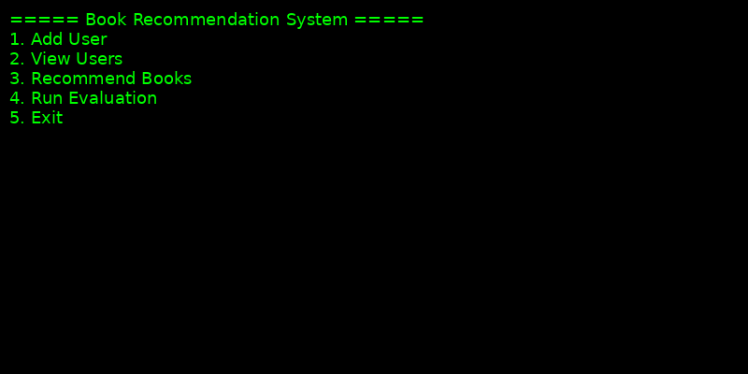

Create user:
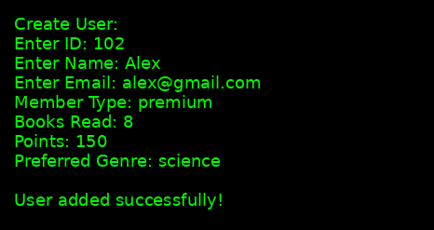

Search result:
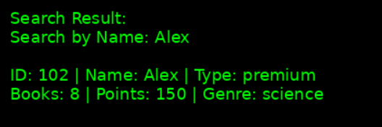

Update succeeded:
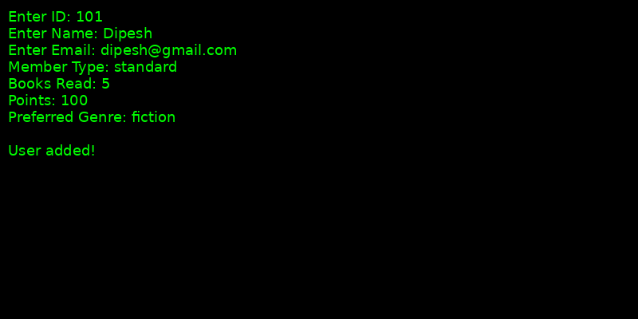

Delete succeeded:
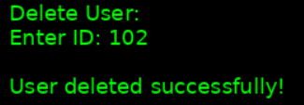

Evaluation result:


Recommendation result:
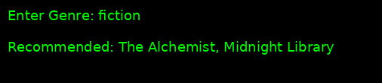
These screenshots should be included in the final report after the test case discussion to help visualise system execution.

9.3 Output Verification
This section verifies that the system output includes correct user information, recommendations, and points after evaluation. It also confirms that all changes are correctly saved and persisted in the members.csv file.

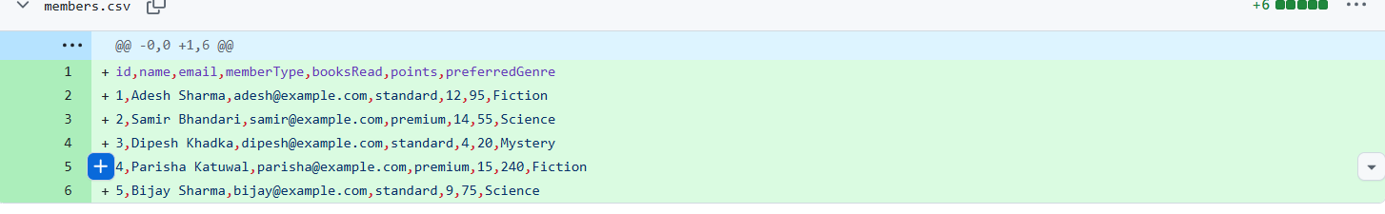

10 Conclusion
The project meets the key objectives of ICT711 Assessment 3 through the use of object-oriented design, CRUD operations, the Java Collections Framework, file handling, exception handling, and a command-line interface.
The inclusion of LibraryUser, StandardMember, and PremiumMember demonstrates key object-oriented programming concepts such as inheritance, polymorphism, abstraction, and encapsulation.
Although the system is relatively small, it successfully achieves the required functionality and can be scaled in the future. Possible enhancements include adding separate book classes, a dedicated file manager class, and more advanced recommendation algorithms. Therefore, the system is suitable for the assessment and serves as effective documentation for a group project.

11 Java Source-Code Link
The project report should include a link to the repository containing the Java source code and data files.
Source Code Repository:
Project Link

